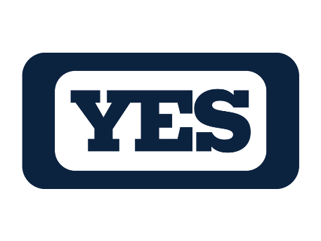

**YES NETWORK**

**Overview**

The YES Network, the most-watched regional sports network in the country for 18 of the last 21 years, owns the exclusive regional media rights of the 27-time World Champion New York Yankees and the Brooklyn Nets. YES, which has earned 146 Emmy Awards since its 2002 launch, also televises original biography, interview and magazine programs, college sports and Manchester City and AC Milan soccer. YES made the list of *Forbes’* top 10 most valuable sports business brands in the world for nine straight years. The YES App was the #1 free sports app in the Apple App Store upon its March 2021 launch and has won two Emmy Awards in its first two years of eligibility.

**CEO**

Jon D. Litner

**Launch**

March 19, 2002

**New York Yankees on YES**

YES owns the exclusive regional media rights to the New York Yankees. In addition to televising Yankees games, YES also televises live pre- andpost-game shows, the *Yankees Batting Practice Today* show and Spring Training games. OtherYankees-themed programs include *Homegrown:* *The Path to Pinstripes*, the Emmy-nominated docu-series providing a revealing look at the Yankees’ best minor league prospects; *Yankeeography*, the Emmy award-winning biography series on past and present Yankees greats; *Yankeeography: Moments of Glory,* which highlights some of the greatest moments in recent Yankees history; *Yankees Magazine*, the weekly magazine show consisting of Yankees highlights, player profiles, behind-the-scenes features and interviews; and classic Yankees games.

**Brooklyn Nets on YES**

The YES Network owns the exclusive regional media rights to the Brooklyn Nets. YES televises regular season, pre-season and post-season Nets games, and pre- and post-game shows for all of its Nets game telecasts. *Nets Magazine* is the magazine show containing Nets highlights, player profiles, behind-the-scenes pieces, exclusive interviews and instructional segments featuring the Nets. YES also televises *Homegrown:* *Bridge To Brooklyn*, an original series focusing on the Nets’ G-League team, the Long Island Nets.

**Additional YES Programming**

YES airs live daily simulcasts of ESPN Radio New York’s *The Michael Kay Show;* the Emmy-winning *Forbes SportsMoney* covers the latest sports business news and trends; YES televises college basketball, football and other sports, and airs Manchester City and AC Milan soccer matches in addition to those clubs’ various magazine shows; YES’ *CenterStage with Michael Kay* features intimate sit-down interviews with sports, media and entertainment celebrities conducted by Kay in front of a live studio audience.

-more-

2-2-2

**YES App**

The YES Network is available via the YES App at no extra cost to fans in YES’ regional coverage territory who receive YES through their traditional pay television service providers, and it is also available via the YES App to fans through a direct-to-consumer subscription offering.

The YES App launched on March 10, 2021 as the official streaming home of the YES Network, and quickly became the #1 free sports app in the Apple App Store. It provides fans with a live stream of the YES Network, in addition to personalized notification features, alternate feeds and game highlights. The app also features first-of-their-kind Live Stats and Watch Party offerings in conjunction with its streamed Yankees and Nets telecasts, as well as a host of app-exclusive original sports and lifestyle programming series.

In addition, the YES App live streams New York Liberty and Long Island Nets G League basketball games and New York City summer playground basketball games, while also hosting several podcasts.

The YES App won New York Emmy Awards in 2023 and 2022, its first two years of eligibility.

-YES-

*5/28/24*