LOCAL COMPETITION ANNOUNCEMENT PRESS RELEASE
FOR IMMEDIATE RELEASE
Media Information: PitchHitRun@mlb.com
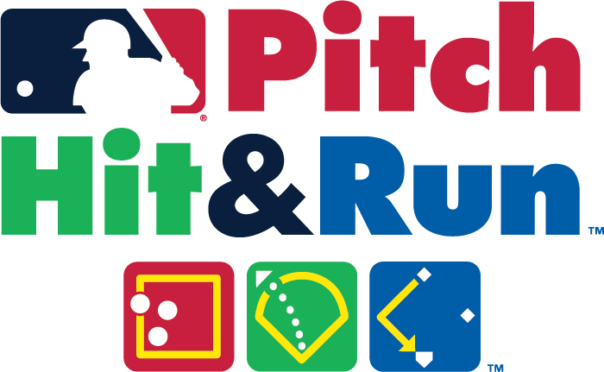
AREA YOUTH TO COMPETE IN
MAJOR LEAGUE BASEBALL® PITCH HIT & RUN™ COMPETITION
______________________________will
host a free Major League
Baseball® Pitch Hit & Run™
Competition for area youth.

Date_______________Time__________
Location__________________________

Pitch Hit & Run™ is the official skills competition of Major League Baseball®. This grassroots program is designed to provide youngsters with an opportunity to compete, free of charge, in a competition that recognizes individual excellence in core baseball/softball skills.

Boys and girls are divided into four age divisions: 7/8, 9/10, 11/12, 13/14, and have the chance to advance through three levels of competition, including Team Championships at Major League Baseball® ballparks and the Finals during MLB™ All-Star Week®.

All participants should register online at PitchHitRun.com and plan to bring age verification (copy/picture of birth certificate or similar) to the competition. For questions concerning the competition, please contact your Local Coordinator, _______________________________at _______________________________________.

