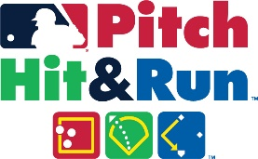

LOCAL COMPETITION RESULTS PRESS RELEASE
FOR IMMEDIATE RELEASE
Media Information: PitchHitRun@mlb.com

AREA YOUTH WIN HONORS IN MAJOR LEAGUE BASEBALL®
PITCH HIT & RUN™ COMPETITION

As many as ____ participants competed in the PITCH HIT & RUN™ Competition hosted by ____________________ on _________________ at ____________________.

These participants won in their respective age groups. They are:

BASEBALL | NAME | HOMETOWN
AGE 7/8 CHAMPION
AGE 9/10 CHAMPION
AGE 11/12 CHAMPION
AGE 13/14 CHAMPION

SOFTBALL | NAME | HOMETOWN
AGE 7/8 CHAMPION
AGE 9/10 CHAMPION
AGE 11/12 CHAMPION
AGE 13/14 CHAMPION

The winners are now eligible to advance to the Team Championship level once all Local events in the market have been completed and scores are ranked.

PITCH HIT & RUN™ is the Official Skills Competition of Major League Baseball. For more information on the program, please visit PitchHitRun.com

