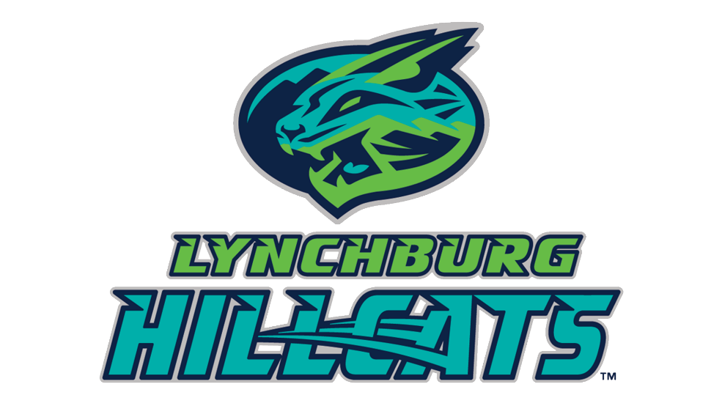
2024 FAMILY CAMPOUT WAIVER FORM
REQUEST AND RELEASE
I have requested permission to enter and participate in the 2024 Lynchburg Hillcats Family Campout Night to be conducted in conjunction with a Lynchburg Hillcats baseball game at Bank of the James Stadium, located in Lynchburg, Virginia.
I acknowledge that I know the risks and dangers involved in the activities associated with this promotion and that unanticipated and unexpected dangers may arise during such activities. I freely assume all such risk of injury to my person and property, both known and unknown, that may be sustained in connection with the promotion or activities, in and about the premises.
In consideration of the permission granted to me to participate in the promotion or stated activities, I agree to exercise care in participating so as to limit the risk of injury to others and myself. In addition, I hereby for myself, my heirs, administrators and assigns, release and discharge the owners, operators, and sponsors of Bank of the James Stadium, including but not limited to Elmore Sports Group, Diamond Creations, and Lynchburg Baseball Corp., the promotion and their respective agents, officers, employees and officials, and all other participants in the promotion or stated activities, of and from any and all claims, demands, actions, and causes of actions of any nature, for injuries sustained to my person and/or property during my presence at Bank of the James Stadium and my participation in the promotion or stated activities due to their negligence or any other fault.
I represent and certify that my age is _________, and if I am under the age of 18 years, I represent and certify that I have the permission of my parents and/or guardians to participate in the promotion or stated activities, and that they have full knowledge thereof and approve of my participation.
I HAVE READ AND UNDERSTOOD THE FOREGOING REQUEST AND RELEASE, FULLY UNDERSTAND ITS TERMS, UNDERSTAND THAT I HAVE GIVEN UP SUBSTANTIAL RIGHTS BY SIGNING IT, AND SIGN IT FREELY AND VOLUNTARILY WITHOUT ANY INDUCEMENT. IN WITNESS WHEREOF, I have executed this Request and Release at Bank of the James Stadium, Lynchburg, Virginia on _______________, 2024.
____________________________________________ ____________________________________________
(Print Participant's Name) (Participant's Signature)
Address: ___________________________________________________________________________________
City: __________________________ State: __________________ Zip: __________________________
Phone:_______________________________________________________
Email: _______________________________________________________
This is to certify that I, as parent/guardian with legal responsibility for this participant, do consent and agree to his/her release as provided above all the Releases’, and, for myself, my heirs, assigns, and next of kin, I release and agree to indemnify and hold harmless the Releases’ from any and all liabilities incident to my minor child’s involvement or participation in these programs as provided above.

___________________________________________ ______________________________________________
(Print Parent/Guardian Name) (Parent/Guardian Signature)

