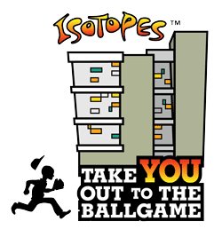
TAKE YOU OUT TO THE BALL GAME
2022 TICKET REQUEST FORM

Organization Name:____________________________________________________________________

Contact:________________________________________ Phone:_______________________________

Organization Address:________________________________________________________________ __

City, State, Zip Code:___________________________________ Fax:____________________________

Contact E-mail________________________________________ 501 (C) (3) #:_____________________

Wheelchair seating needed? Yes ____ No ____ if yes, how many: _____
Companion seating needed? Yes _____ No _____ if yes, how many: _____

Wheelchair/Companion TOTAL: _____ + Regular Reserved Seating TOTAL: _____ = TOTAL NUMBER OF TICKETS: _____

PLEASE ATTACH A LETTER OF REQUEST AND MISSION STATEMENT ON YOUR ORGANIZATION’S LETTERHEAD.
Tickets are limited and are dependent upon availability. Filling out a form does not guarantee selection. Selected groups will be notified as soon as tickets become available.

AN ISOTOPES REPRESENTATIVE WILL REACH OUT TO YOUR ORGANIZATION WHEN TICKETS ARE AVAILABLE. PLEASE DO NOT CONTACT TO ASK ABOUT TICKET AVAILABILITY.
2022 HOME GAME SCHEDULE
SUNDAY – THURSDAY GAMES ONLY
 | 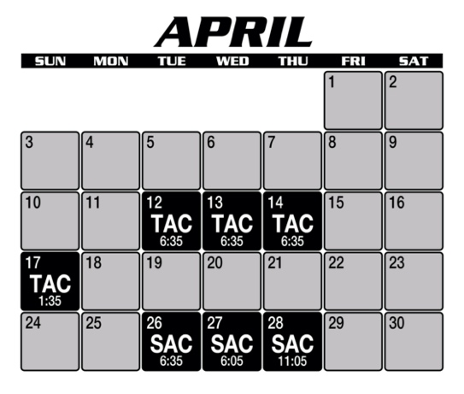  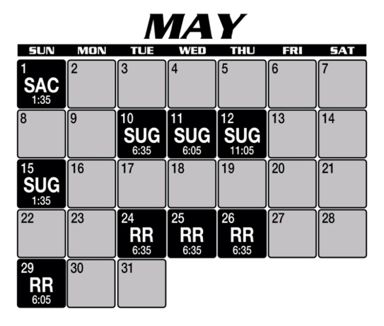  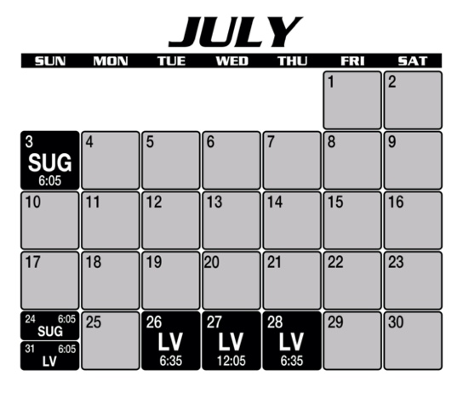  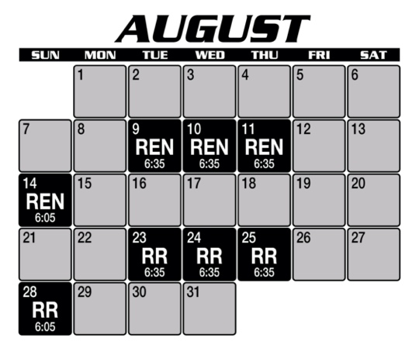  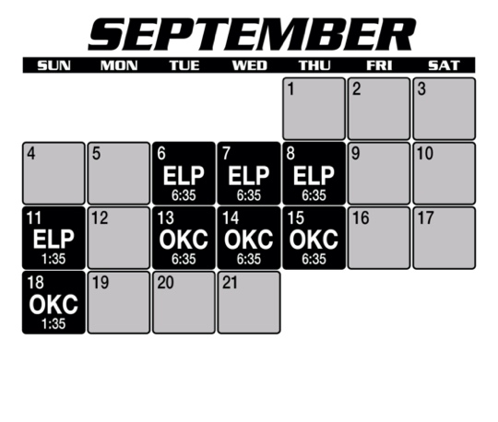 |  | 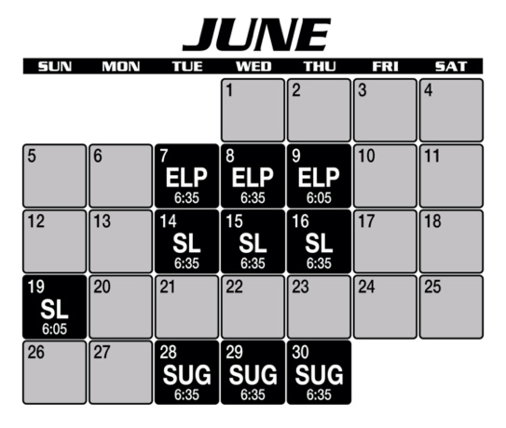

Or send to Michelle Montoya
mmontoya@ABQIsotopes.com
Fax 505-242-8899

RETURN FORM TO:

Take You Out to the Ball Game Request
1601 Avenida Cesar Chavez SE
Albuquerque, NM 87106

